PURPOSE/DIRECTIONS: Before we talk about macromolecules, I want you to “preview” each of the 4 classes of macromolecules that are important in biology: carbohydrates, lipids, proteins, and nucleic acids.
-Read the brief summaries below and HIGHLIGHT important information that you find.
-After reading and highlighting, answer the questions that follow. Be sure to make note of anything you are confused about so we can talk about it during notes. DO NOT EXPECT TO UNDERSTAND ALL OF THIS! It’s ok, we will learn it over the next few weeks together 😊

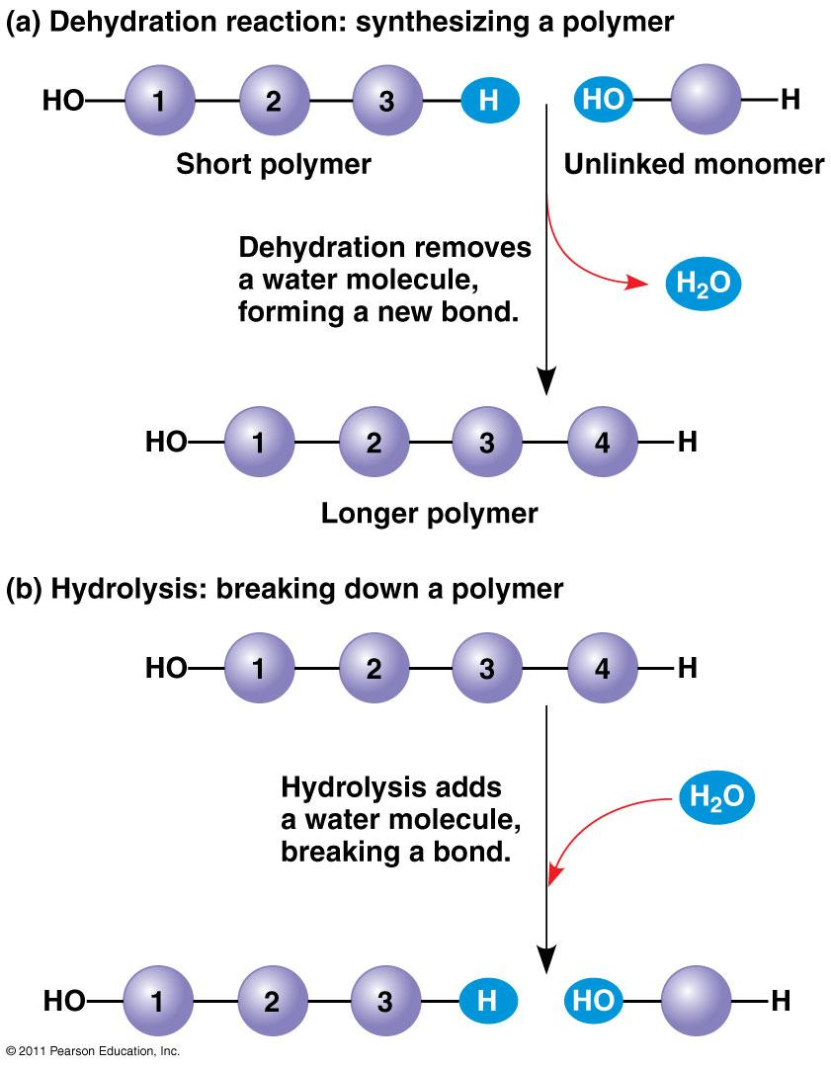
Biological Macromolecules:
The most common elements in living things are carbon, hydrogen, nitrogen, and oxygen. These four elements constitute about 95% of your body weight. All compounds, which are made of two or more elements, can be classified into two broad categories --- organic and inorganic. Organic compounds are all based on carbon, while inorganic compounds are not carbon-based. Carbon is unique because it can form up to 4 single bonds with other atoms OR it can bond to other carbon molecules to form double and triple bonds. Because of this wide variety of options, carbon-based molecules can be different shapes, including single and double rings, chains, and branching chains. Most organic compounds are built primarily of carbon, hydrogen, and oxygen, but in different ratios. Small organic molecules can be a unit of a large organic molecule called a macromolecule. If the small organic units are identical or form patterns, they are called monomers and the large organic molecule they form is called a polymer.
When monomers are joined together, the reaction is called dehydration synthesis as water is produced when the monomers are bonded together. To break the polymers down into monomers, the reaction is called hydrolysis (see the picture to the right).
There are four classes of macromolecules: carbohydrates, lipids, proteins, and nucleic acids. Heterotrophs, like us, must get many of these biological macromolecules from our food, which we break down into monomers through digestion. This makes the molecules small enough to cross cell membranes. Our cells the use them either as energy sources or to build the carbohydrates, proteins, lipids, and nucleic acids that our body needs.

Questions:
- What is the difference between organic and inorganic compounds?

What makes carbon unique in terms of its bonding ability?

What are macromolecules?
- How are monomers related to polymers?

When polymers are built, the reaction is called a dehydration synthesis. Why is the word “dehydration” used?
- What is the name of the reaction that breaks apart polymers into monomers?
- Why does a cell (or your body) need to break down polymers into monomers?
- Life’s large molecules, or macromolecules, are classified into what four categories?

Carbohydrates:
Carbohydrates are simple sugars, starches, and glycogen. Carbohydrates are used for short and long-term energy storage in cells and they can be structural molecules in cell walls and exoskeletons. Carbohydrates are made of carbon, hydrogen, and oxygen (CHO). They are found in bread, potatoes, pasta, and fruits.
The simplest carbohydrates are called monosaccharides. Monosaccharides, or simple sugars, include glucose, galactose, and fructose and they are monomers. Two simple sugars combine to make disaccharides (double sugars like lactose [milk sugar] and sucrose [table sugar]), and many monosaccharides joined together make polysaccharides, which are polymers (cellulose, chitin, starch, and glycogen).
Plants store glucose as starch, which is simply long chains of glucose with a few side branches. Animals store glucose as glycogen, which is also a long chain that is more branched. Cellulose makes up plant cell walls and is composed of three chains of glucose twisted together like a rope.

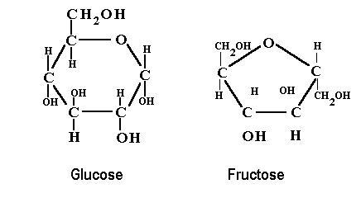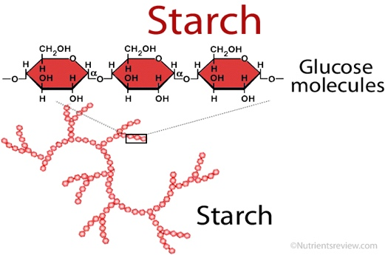

Questions:
- What are two functions of carbohydrates?

What are the simplest types of carbohydrates (the monomers) called?
- What is the name of a carbohydrate polymer (many monosaccharides joined)?

- In the list below circle the polysaccharide(s), underline the disaccharide(s), and put a star next to the monosaccharide(s).
cellulose glucose fructose starch sucrose

glycogen lactose galactose

Lipids:
Lipids are used for cell membranes, long-term energy storage, and insulation. Lipids are large, hydrophobic (won't dissolve in water) molecules. Because of this property, they serve as waxy coverings on plant leaves to prevent dehydration and on the feathers of aquatic birds to keep them dry in the water. Lipids can also be pigments (chlorophyll), hormones (estrogen, testosterone, adrenaline), and sterols (cholesterol).
Fats and oils are lipids made of a glycerol molecule and three fatty acid chains; this structure is called a triglyceride (see next page). The fatty acid chains are saturated (only single bonds between carbons) in fats and unsaturated (contain at least one double bond) in oils; this is why fats are generally solid at room temperature and oils are liquid at room temperature.
TRIGLYCERIDE 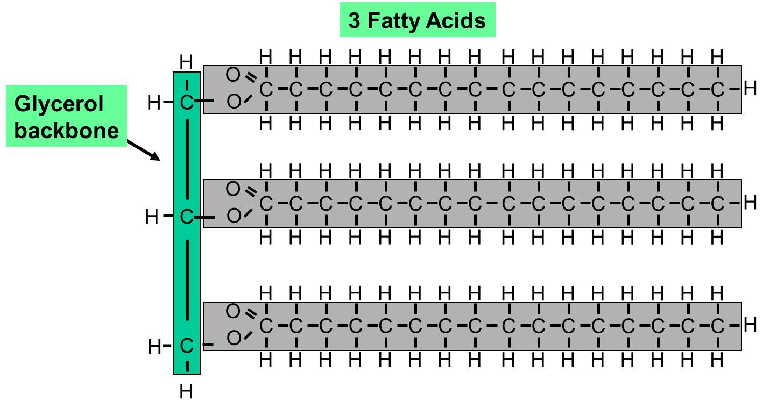
A special type of lipid called a phospholipid (see below) makes up the cell membrane. Instead of three fatty acids and a glycerol, one of the fatty acids is replaced by a phosphate group
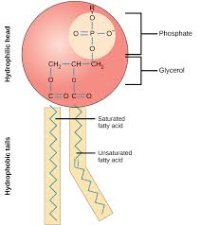
Questions:
- What are three functions of lipids?
- Why are lipids useful as a barrier to water on the surfaces of plants and feathers (what do all lipids have in common)?

- What are the parts of a triglyceride?

- What is the difference between a fat and an oil?
- What is the function of phospholipids?
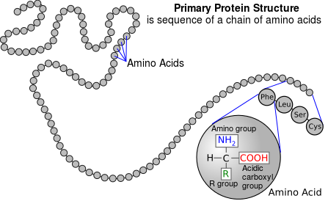
Proteins:
Proteins make up the majority of the structure of plants and animals and act as enzymes to speed up chemical reactions. Proteins consist primarily of the elements CHON and are made of monomers called amino acids. The bonds between amino acids are called peptide bonds and many amino acids joined together form a polypeptide (polymer).
Each amino acid has different properties and the order of amino acids in a protein determines that protein’s structure. Furthermore, a protein’s structure determines its function, or job. If the temperature or pH of a cell changes, this can change how the amino acids interact and damage or denature (unfold) the protein, meaning it can no longer do its job.

Questions:

What monomers make up proteins?
- What are two functions of proteins?
- What determines a protein’s function?

- What would happen to a protein if the pH or temperature changes?

Nucleic Acids:
Nucleic acids are DNA (deoxyribonucleic acid) and RNA (ribonucleic acid). DNA and RNA (which are both polymers) contain carbon, hydrogen, oxygen, nitrogen, and phosphorus (CHONP). DNA contains all the instructions for making every protein needed by a living thing, and RNA copies and transfers this genetic information so that proteins can be made. The monomers that make up nucleic acids are called nucleotides.
Nucleotides themselves are made of a phosphate group attached to a pentose (5- carbon) sugar and a nitrogenous (contains lots of nitrogen) base. In DNA, the sugar is deoxyribose and the nitrogenous bases are adenine, guanine, cytosine, and thymine (AGCT). DNA is two strands of nucleotides attached in the middle by hydrogen bonds. RNA has ribose as its sugar and the same AGC bases as DNA but the T is swapped for U (uracil). RNA is a single strand of nucleotides.

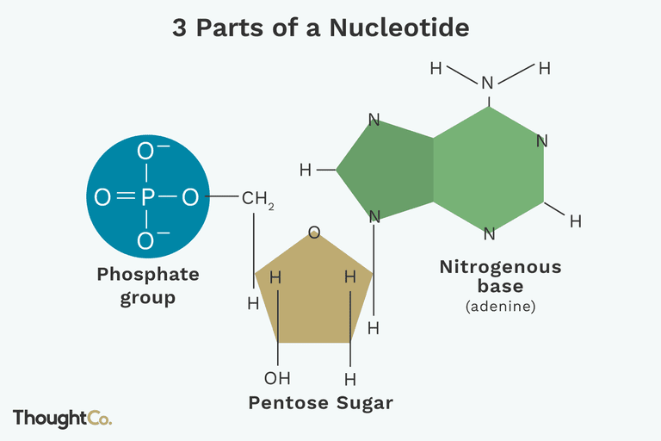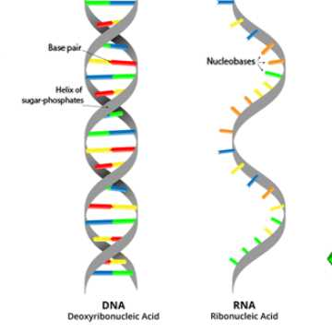

Questions:
- Name the two nucleic acids and give their general function.
- What is the monomer of nucleic acids?
- What are the three parts of this monomer?

