LABORATORY 5: CELL RESPIRATION

OVERVIEW

In this experiment, you will work with seeds that are living but dormant. A seed contains an embryo plant and a food supply surrounded by a seed coat. When the necessary conditions are met, germination occurs, and the rate of cellular respiration greatly increases. In this laboratory you will measure oxygen consumption during germination. You will measure the change in gas volume in respirometers containing either germinating or nongerminating pea seeds. In addition, you will measure the rate of respiration of these peas at two different temperatures.

OBJECTIVES

Before doing this laboratory you should understand:
- how a respirometer works in terms of the gas laws: and
- the general processes of metabolism in living organisms.

After doing this laboratory you should be able to:
- calculate the rate of cell respiration from experimental data;
- relate gas production to respiration rate; and
- test the effect of temperature on the rate of cell respiration in ungerminated versus germinated seeds in a controlled experiment.

INTRODUCTION

Cellular respiration is the release of energy from organic compounds by metabolic chemical oxidation in the mitochondria within each cell. Cellular respiration involves a series of enzyme-mediated reactions.

The equation below shows the complete oxidation of glucose. Oxygen is required for this energy-releasing process to occur.

C₆H₁₂O₆ + 6 O₂ 6 CO₂ + 6 H₂O + 686 kilocalories of energy/mole of glucose oxidized

By studying the equation above, you will notice there are three ways cellular respiration could be measured. One could measure the:

- Consumption of O₂. (How many moles of O₂ are consumed in cellular respiration?)

- Production of CO₂. (How many moles of CO₂ are produced in cellular respiration?)

- Release of energy during cellular respiration.

In this experiment, the relative volume of O₂ consumed by germinating and nongerminating (dry) peas at two different temperatures will be measured.

Background Information

A number of physical laws relating to gases are important to the understanding of how the apparatus that you will use in this exercise works. The laws are summarized in the general gas law that states:
PV = nRT

where
P is the pressure of the gas,
V is the volume of the gas,
n is the number of molecules of gas,
R is the gas constant (its value is fixed), and
T is the temperatures of the gas (in ºK).

This law implies the following important concepts about gases:

- If temperature and pressure are kept constant, then the volume of the gas is directly proportional to the number of molecules of the gas.

- If the temperatures and volume remain constant, then the pressure of the gas changes in direct proportion to the number of molecules of gas present.

- If the number of gas molecules and the temperature remain constant, then the pressure is inversely proportional to the volume.

- If the temperature changes and the number of gas molecules is kept constant, then either pressure or volume (or both) will change in direct proportion to the temperature.

It is also important to remember that gases and fluids flow from regions of high pressure to regions of low pressure.

In this experiment, the CO₂ produced during cellular respiration will be removed by potassium hydroxide (KOH) and will form solid potassium carbonate (K₂CO₃) according to the following reaction:

CO₂ + 2 KOH K₂CO₃ + H₂O

Since the CO₂ is being removed, the change in the volume of gas in the respirometer will be directly related to the amount of oxygen consumed.

In the experimental apparatus (Figures 5.1 and 5.2), if water temperature and volume remain constant, the water will move toward the region of lower pressure. During respiration, oxygen will be consumed. Its volume will be reduced, because the CO₂ produced is being converted to a solid. The net result is a decrease in gas volume within the tube, and a related decrease in pressure in the tube. The vial with glass beads alone will permit detection of any changes in volume due to atmospheric pressure changes or temperature changes.

The amount of O₂ consumed will be measured over a period of time. Six respirometers should be set up as follows:

Respirometer | Temperature | Contents
1 | Room | Germinating Seeds
2 | Room | Dry Seeds + Beads
3 | Room | Beads
4 | 10ºC | Germinating Seeds
5 | 10ºC | Dry Seeds + Beads
6 | 10ºC | Beads

PROCEDURE

- Both a room-temperature bath (approximately 25ºC) and a 10ºC bath should be set up immediately to allow for time to adjust the temperature of each. Add ice to attain 10ºC.

- Respirometer 1: Obtain a 100-mL graduated cylinder and fill it with 50 mL of H₂O. Drop in 25 germinating peas and determine the amount of water that was displaced (which is equivalent to the volume of peas). Record the volume of 25 germinating peas. Remove these peas and place them on a paper towel. They will be used in respirometer 1.

Pea Volume ___________________ mL

- Respirometer 2: Refill the graduated cylinder with 50 mL of H₂O. Drop 25 dried peas (not germinating) into the graduated cylinder and then add enough glass beads to attain a volume equivalent to that of the expanded germinating peas. Remove these peas and beads and place them on a paper towel. They will be used in respirometer 2.

- Respirometer 3: Refill the graduated cylinder with 50 mL of H₂O. Determine how many glass beads would be required to attain a volume equivalent to that of the germinating peas. Remove these beads and place them on a paper towel. They will be used in respirometer 3.

- Repeat the procedures above to prepare a second set of germinating peas, dry peas plus beads, and beads for use in repirometers 4, 5 and 6 respectively.

- To assemble the six respirometers, obtain six vials, each with an attached stopper and pipette. Place a small wad of absorbent cotton in the bottom of each vial and, using a dropper, saturate the cotton with 15% KOH. Make sure that the respirometer vials are dry on the inside. Do not get KOH on the sides of the respirometer. Place a small wad of dry cotton on top of the KOH-soaked absorbent cotton (Figure 5.1). It is important that the amounts of cotton and KOH be the same for each respirometer.

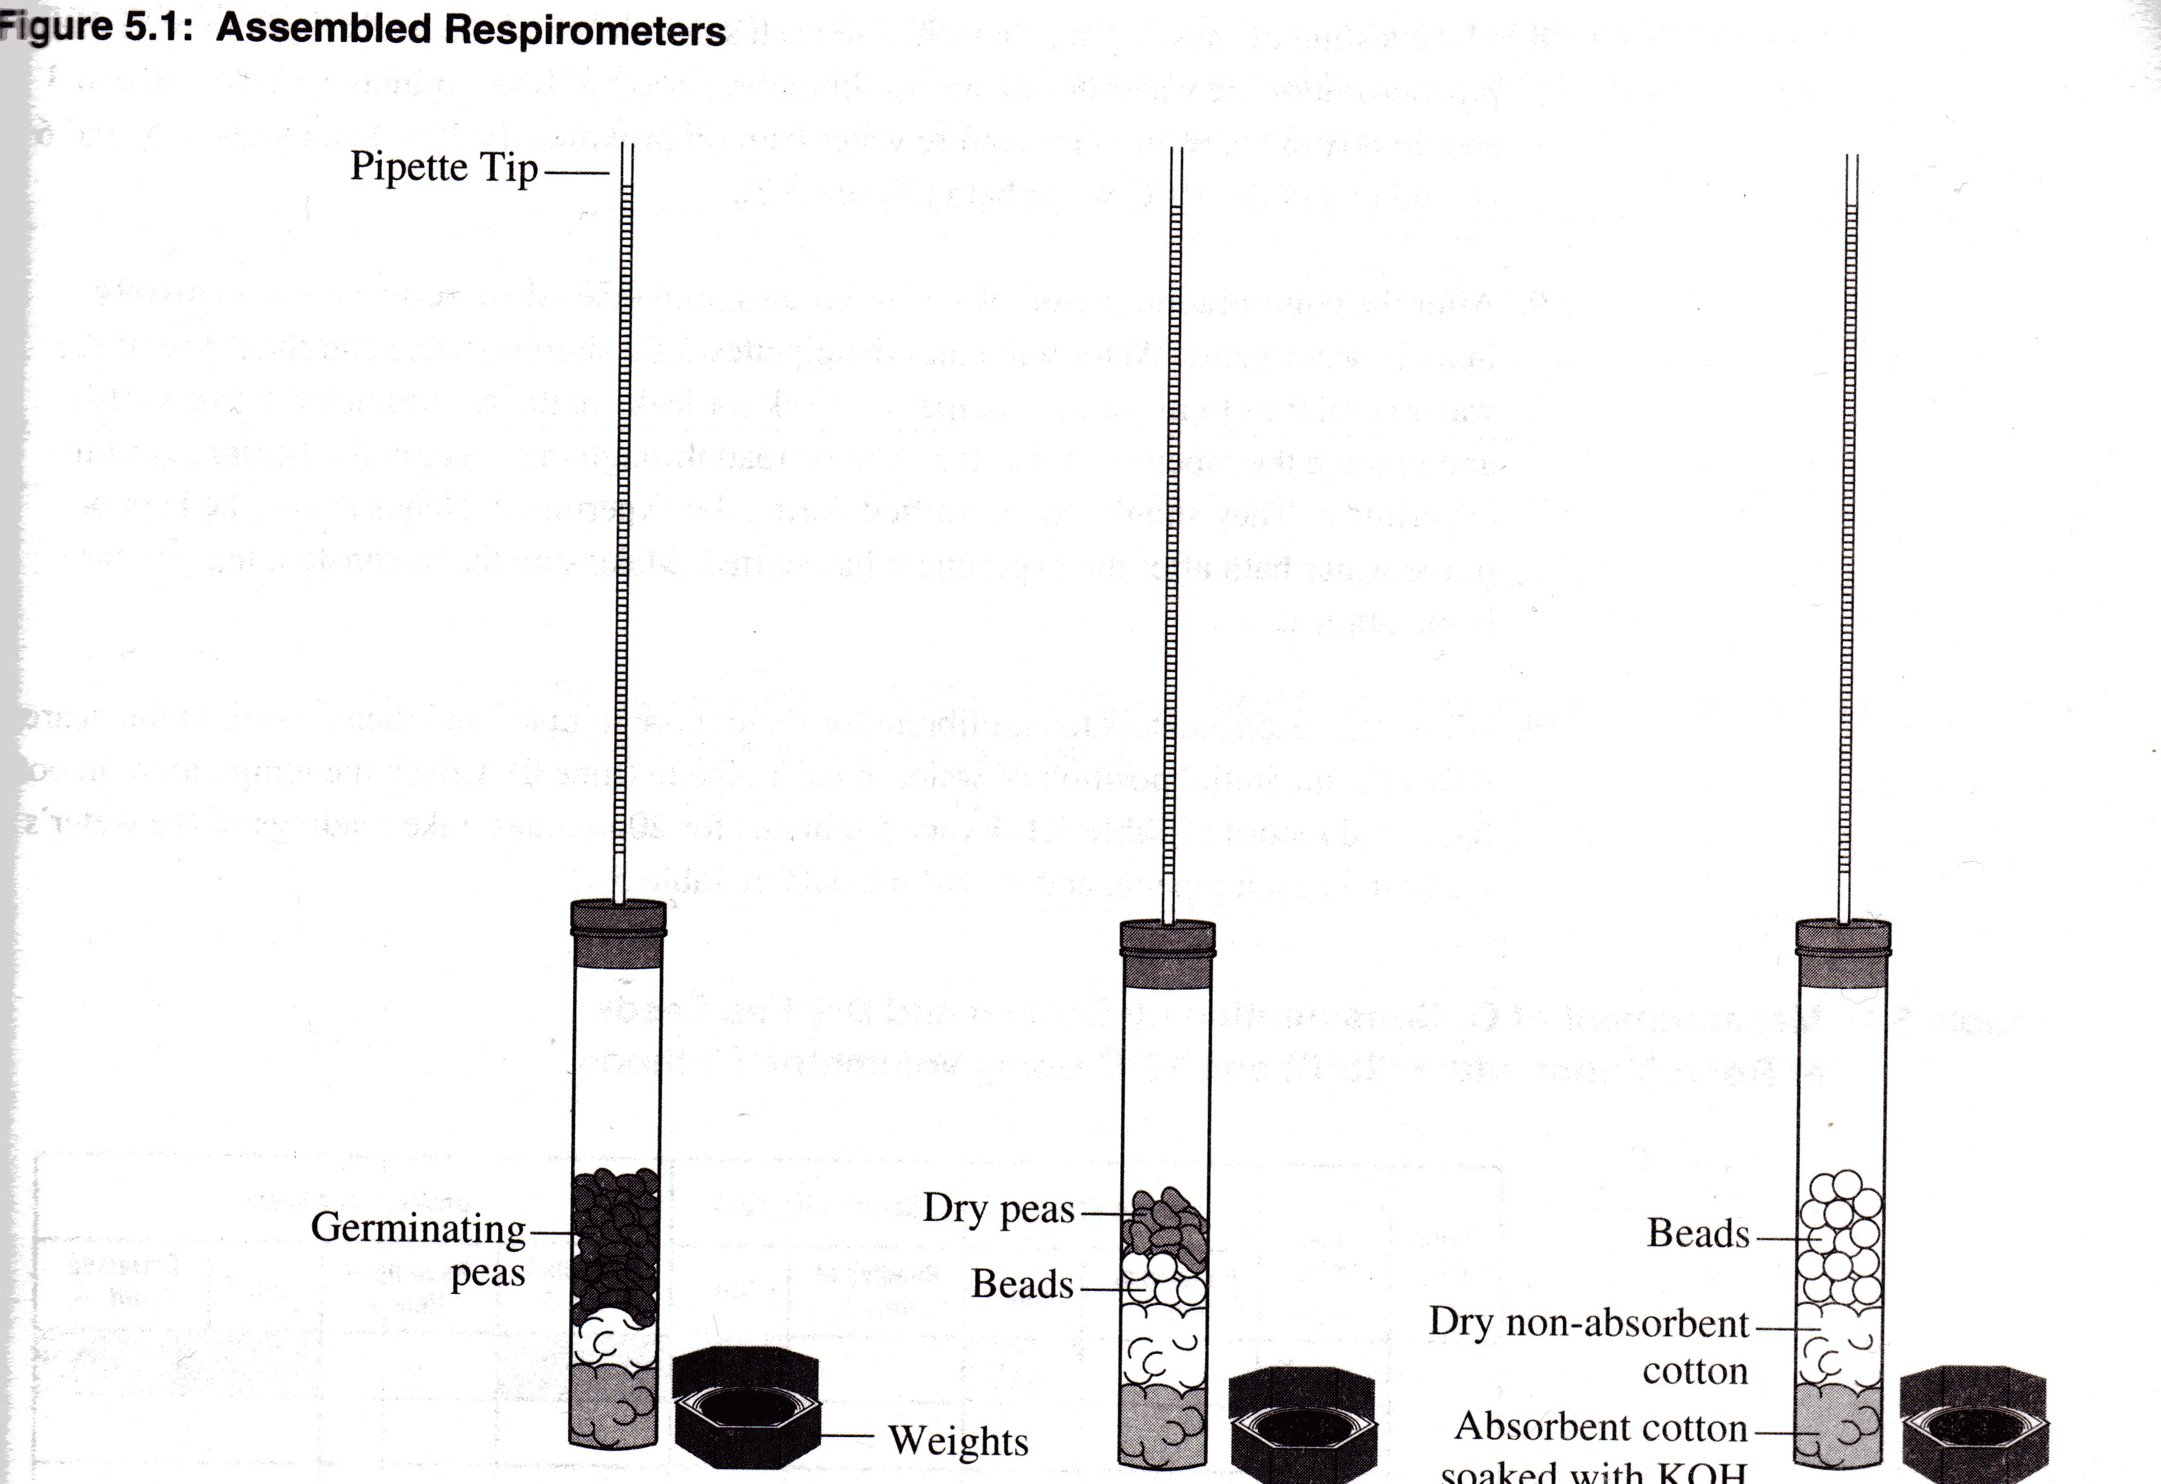

- Place the first set of germinating peas, dry peas + beads, and beads in vials 1, 2 and 3, respectively. Place the second set of germinating peas, dry peas plus beads, and beads in vials 4, 5, and 6 respectively. Insert the stopper fitted with the calibrated pipette. Place a weighted collar on each end of the vial (Figure 5.2).

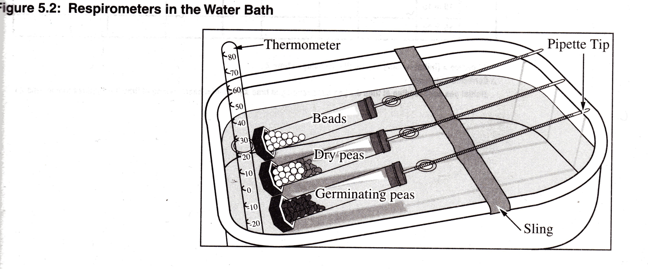

- Make a sling of masking tape attached to each side of each of the water baths to hold the pipettes out of the water during an equilibration period of seven minutes. Vials 1, 2 and 3 should rest in the room-temperature water bath (approximately 25º C) and vials 4, 5 and 6 should rest in the 10º C water bath (Figure 5.2).

- After the equilibration period of seven minutes, immerse all six respirometers entirely in their water baths. Water will enter the pipettes for a short distance and then stop. If the water continues to move into a pipette, check for leaks in the respirometer. Work swiftly and arrange the pipettes so that they can be read through the water at the beginning of the experiment. They should not be shifted during the experiment. Hands should be kept out of the water bath after the experiment has started. Make sure that a constant temperature is maintained.

- Allow the respirometers to equilibrate for three more minutes and then record, to the nearest 0.01 mL, the initial position of water in each pipette (time 0). Check the temperature in both baths and record in Table 5.1. Every 5 minutes for 20 minutes, take readings of the water’s position in each pipette, and record the data in Table 5.1.

Table 5.1: Measurement of O₂ Consumption by Soaked and Dry Pea Seeds at Room Temperature (25ºC) and 10ºC Using Volumetric Methods

Temp (ºC) | Time (min) | Beads Alone |  | Germinating Peas |  | Dry Peas and Beads
Temp (ºC) | Time (min) | Reading at time X | Diff.* | Reading at time X | Diff. * | Corrected Difference  | Reading at time X | Diff. * | Corrected Difference  
 | Initial - 0
 | 0 to 5
 | 5 to 10
 | 10 to 15
 | 15 to 20
 | Initial - 0
 | 0 to 5
 | 5 to 10
 | 10 to 15
 | 15 to 20

* Difference = (initial reading at time 0) – (reading at time X)
❒ Corrected difference =
(initial pea seed reading at time 0 – pea seed reading at time X) – (initial bead reading at time 0 – bead reading at time X)

- Graph the results from the corrected difference column for the germinating peas and the dry peas at both room temperature and at 10ºC.

For this graph you will need to determine the following:

a. the independent variable _________________________________________
Use this to label the horizontal (X) axis.

b. the dependent variable __________________________________________
Use this to label the vertical (Y) axis.

ANAYLYSIS OF RESULTS

- In this activity, you are investigating both the effect of germination versus non-germination and warm temperature versus cold temperature on respiration rate. Identify the hypothesis being tested in this activity.
- This activity uses a number of controls. Identify at least three of the controls, and describe the purpose of each control.

- Describe and explain the relationship between the amount of O₂ consumed and time.

- From the slope of the four lines on the graph, determine the rate of O₂ consumption of germinating and dry peas during the experiment at room temperature and at 10º C. Recall that rate =  y/  x

Condition | Show Calculations Here | Rate in mL O₂ / minute
Germinating Peas/10ºC
Germinating Peas/Room Temperature
Dry Peas/10ºC

Dry Peas/Room Temperature

- Why is it necessary to correct the reading from the peas with the readings from the beads?

- Explain the effect of germination (versus non-germination) on pea seed respiration.

- Below is a sample graph of possible data obtained for oxygen consumption by germinating peas up to about 8ºC. Draw in predicted results through 45ºC. Explain your prediction.

- What is the purpose of KOH in this experiment?

- Why did the vial have to be completely sealed around the stopper?

- If you used the same experimental design to compare the rates of respiration of a 25 g. reptile and a 25 g. mammal, at 10ºC, what results would you expect? Explain your reasoning.

- If respiration in a small mammal were studied at both room temperature and 10ºC, what results would you predict? Explain your reasoning.

- Explain why water moved into the respirometers’ pipettes.

- Design an experiment to examine the rates of cellular respiration in peas that have been germinating for 0, 24, 48 and 72 hours. What results would you expect? Why?

