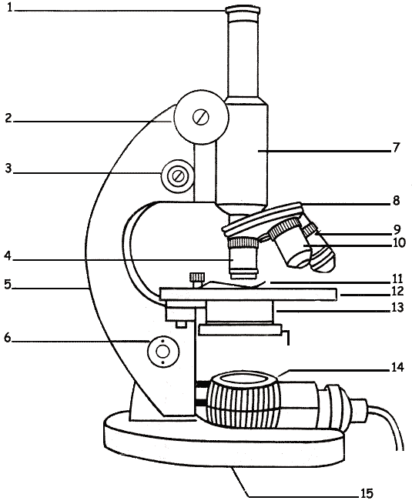

**Eyepiece/ocular**



**Stage**

**Stage clips**

**Diaphragm**

**Light source**

**Base**

**Arm**

**High power objective**

**Low power objective**

**Revolving nosepiece**

**Body tube**

**Fine adjustment**

**Coarse adjustment**