DIFFUSION/OSMOSIS VIRTUAL LAB
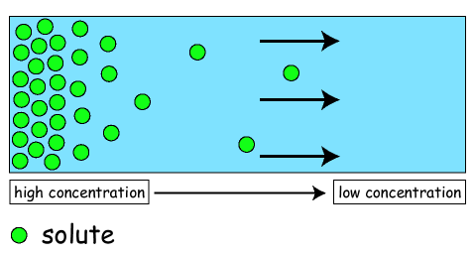
DIFFUSION
Go to Pardues World for today. Click on the link "Diffusion" to see the information in this section.

*** Remember that solutes are things that are dissolved and solvents are things that do the dissolving.

- Is diffusion active or passive transport of particles across the cell membrane? __________________
- In the very beginning, how does the concentration of the blue particles on side A compare to that of side B?

- What 3 things can molecules moving with kinetic energy do?
a.
b.
c.

- Net diffusion moves down the concentration gradient from areas of ________________ concentration to areas of ________________ concentration.
- Eventually the two sides will come to equilibrium. What is equilibrium?

- What happens to the movement of molecules when their temperature is raised? ________________
7. lowered? ________________

Watch the video: "How diffusion works".
After the video, scroll down and take the quiz. Write the correct answers below.
1.
2.
3.
4.
5.

OSMOSIS
Click on the link "Osmosis" to see information in this section.
8. What is osmosis?

9. What does the dashed line in the beaker separating the two sides represent? _______________________

10. Why are they assuming the large molecules will stay on their own side of the membrane?

11. Because molecules will move from one side to another to come to an equilibrium, or balance of concentration, the ________________________ moves from side B to side A, so the water level on side A goes _____________________________.

12. In living things, cells must be in a ________________________ solution where water leaves and enters the cell at ________________________________.

13. What happens to a cell in a concentrated, hypertonic environment? Click on the "View Movie" icon to find out.

14. What happens to a cell in a concentrated, hypotonic environment? Click on the "View Movie" icon to find out.

Watch the video: "How Osmosis Works".
After the video, scroll down and take the quiz. Write the correct answers below.
1.
2.
3.
4.
5.

VIRTUAL LAB
Go to the "Virtual Lab" link to answer the questions below.
Read and scroll through the information on the left and follow the directions for the procedure. Fill in the data table below.

Molecules | Red Blood Cell:  Net water movement: In or Out? | Red Blood Cell: Appearance of Cell | Elodea:  Net water movement: In or Out? | Elodea:  Appearance of Cell | Paramecium:  Net water movement: In or Out? | Paramecium:  Appearance of Cell
Hypotonic
Solution

Isotonic
Solution

Hypertonic
Solution

15. Could Elodea or Paramecium from a freshwater lake be expected to survive if transplanted into the ocean? Explain.

16. If you grill a steak, would it be better to put salt on it before or after you cooked it? Explain in terms of osmosis?

17. Why does salad become soggy and wilted when the dressing has been on it for a while? Explain in terms of osmosis?

18. An effective way to kill weeds is to pour salt water on the ground around the plants. Explain why the weeds die, using the principles discovered in the virtual lab.

19. When salt is put onto a snail or slug, it will bubble up and die. Explain what is occurring.

