Name: ________________________________________________ Period: ______

Introduction to Macromolecules

PURPOSE/DIRECTIONS: Before we talk about macromolecules, I want you to read about organic molecules and “preview” each of the 4 classes of macromolecules that are important in biology: carbohydrates, lipids, proteins, and nucleic acids. Read the brief summaries below and HIGHLIGHT important information that you find. After reading and highlighting, answer the questions that follow. Be sure to make note of anything you are confused about so we can talk about it during notes.

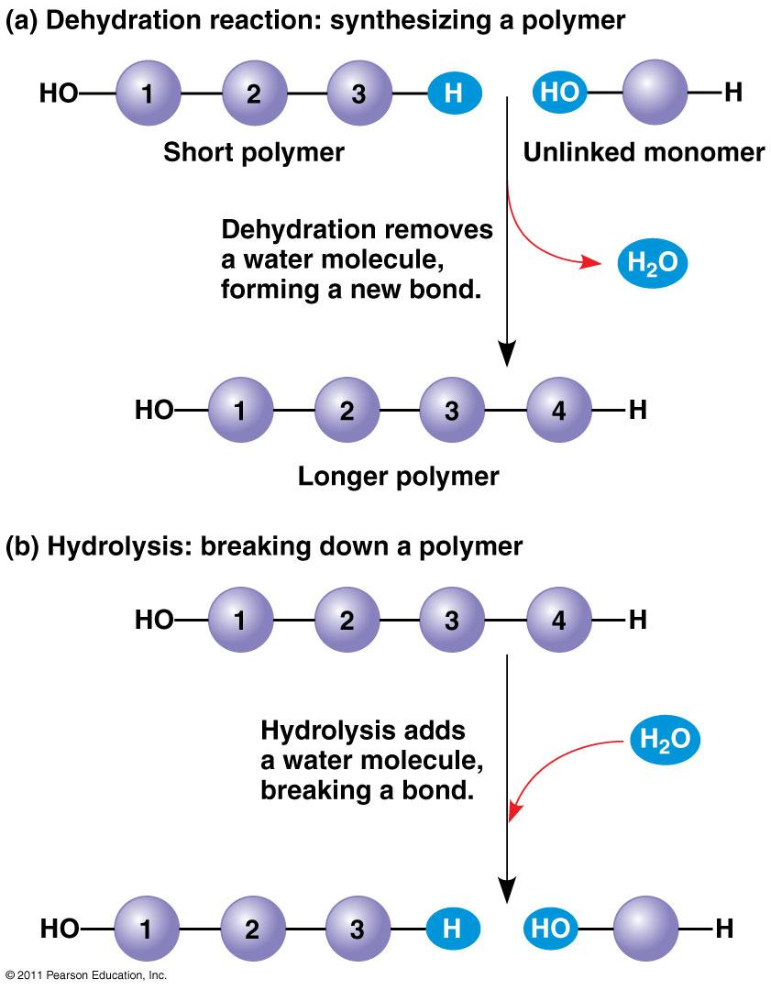
Biological Macromolecules:
The most common elements in living things are carbon, hydrogen, nitrogen, and oxygen. These four elements constitute about 95% of your body weight. All compounds, which are made of two or more elements, can be classified in two broad categories --- organic and inorganic compounds. Organic compounds are all based on carbon. Carbon is unique because it can form up to 4 single bonds with other atoms OR it can bond to other carbon molecules to form double and triple bonds. Because of this wide variety of options, carbon-based molecules can be different shapes, including single and double rings, chains, and branching chains. Most organic compounds are built primarily of carbon, hydrogen, and oxygen, but in different ratios. Small organic molecules can be a unit of a large organic molecule called a macromolecule. If the small organic units are identical or form patterns, they are called monomers and the large organic molecule they form is called a polymer.
When monomers are joined together, the reaction is called dehydration synthesis or condensation as water is produced when the monomers are bonded together. To break the polymers down again the reaction is called hydrolysis. Notice how water is used or produced in these two reactions shown to the right
There are four classes of macromolecules: carbohydrates, lipids, proteins, and nucleic acids. Heterotrophs, like us, must get these biological macromolecules from our food, which we break down into monomers through digestion. This makes the molecules small enough to cross cell membranes. Our cells use them either as energy sources or to build the carbohydrates, proteins, lipids, and nucleic acids that our body needs.

Questions:
- What is the difference between organic and inorganic compounds?

What kinds of shapes can carbon-based molecules form?

What are macromolecules?
- How are monomers related to polymers?

When polymers are built, the process is called a dehydration reaction. Why is the word “dehydration” used?

- Organisms not only build molecules, they also break them down. This chemical reaction is
called _________________________.
- Why does a cell (or your body) need to break down polymers into monomers?
Life’s large molecules, or macromolecules, are classified into what four categories?

