Name _______________________________________
Period _________

Living or Non…that is the Question!

Brainstorming: Get those brain cells warmed up!

- If you were exploring a new ecosystem, like deep in the ocean, or on a distant planet, how would you determine whether a specimen you are observing is alive or not?
- What do you think it means to be alive?
- How is “dead” related to being living? Can something that was never living be dead? Why/why
- not?
- Does everything living have to have the same qualities or characteristics? If so, which ones?
- What characteristics may non‐living things have that make them appear alive?

Purpose:
- In this activity, you will observe and compare specimens in order to determine if they are living or not based on the characteristics of life we have discussed.

Procedure:
- Make observations: Really observe each specimen. Remember, observations mean using your senses (when appropriate). Do not let your preconceived idea of what the specimen might be, but really observe it! If needed, take a moment to write a brief description of the item in the box with its number and name.
- Follow directions: Some specimens have special instructions, be sure to follow those exactly.
- After you have made all of your observations, review the data you collected, fill in the data table and indicate whether you believe the specimen to be Living (L), Nonliving (NL) or Dead (D).

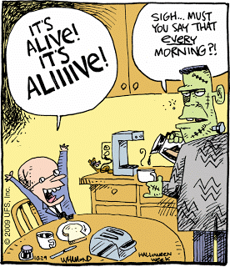
Object # | Specimen | Name any characteristics of life that this object exhibits. (Even nonliving things may exhibit some characteristics of life.) | Is it living, nonliving or dead?  (L, NL, D) | Why?
1
2
3
4
5
6
7

Analysis: Once you are done with the lab, answer the following questions.

- According to your observations, what traits do nonliving things have in common with one another?

- Which characteristics of living things might you have used but were not easily observable?

- What instruments or technologies might have helped you to determine whether or not some of the unknowns are living or not?

- For the following specimens, label them as living (L), nonliving (NL) or dead (D) and then give a short one-sentence explanation for why it belongs in this category. This is NOT means to be a research project. Just answer what you THINK, based on what you have learned after completing this activity. Be ready to defend your answer. (Even if you are ultimately wrong, that’s okay, but really think about which category it belongs.
- HIV virus

- brown grass

- fertilized chicken egg

- egg bought in a grocery store

- the skin on the back of your hand

- hair on a fruit fly’s back

- boiling water

